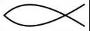
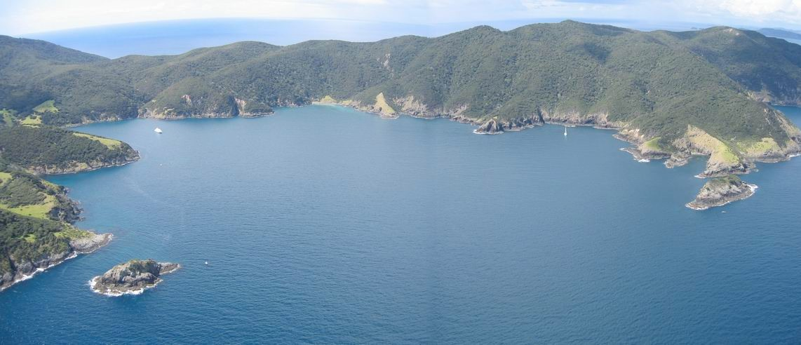
1
TE KUPENGA O NGATI KUTA ME PATUKEHA
KI TE RAWHITI
Patukeha hapu Kaumatua-Moka Puru Ngati Kuta hapu Chairman-Russell Hook Kaitakawaenga-Robert Willoughby Project Manager-Helen Mountain Harte
An Application for an s186a in Maunganui Bay,
Ipipiri, Bay of Islands
October, 2009
Deep Water Cove
Site 3
Subtropical
species
Site 1 – Waitaha Reef
Motuwheteke Island
Putahataha Island
Site 2
Subtropical species
Maunganui Bay
Figure 1: The 2007 survey sites in Maunganui Bay and the areas of subtropical
species

2
TABLE OF CONTENTS
PURPOSE........................................................................................................ 3
THE ROHE MOANA OF NGATI KUTA AND PATUKEHA ............................... 4
OUR CUSTOMARY STATUTORY RIGHTS .................................................... 4
BACKGROUND ............................................................................................... 4
TANGATA WHENUA ....................................................................................... 4
IMPACTS ON CUSTOMARY USE AND MANAGEMENT PRACTICES ......... 5
SPECIES AND BIOLOGICAL INFORMATION ................................................ 6
THE CUSTOMARY KAIMOANA IN MAUNGANUI BAY .................................. 7
SEA GRASS-RIMURIMU TAKEKE.................................................................. 7
SCALLOPS-TIPA ............................................................................................. 8
SNAPPER-TAMURE, CRAYFISH- KOURA .................................................... 8
MAOMAO, ABALONE-PAUA ........................................................................... 9
SEA URCHIN-KINA ......................................................................................... 9
AREA AND BOUNDARY OF THE S186A MAUNGANUI BAY ...................... 10
FISHING METHODS RESTRICTION ............................................................ 10
LENGTH OF S186A RESTRICTION ............................................................. 11
CONSULTATION ALREADY UNDERTAKEN ............................................... 11
SUMMARY ..................................................................................................... 11
3
PURPOSE
This application is for an S186A made under the Fisheries Act 1996 for Maunganui bay in the Bay of Islands within the area set out in Figure 1 on the title page.
This bay has always held customary significance to Ngati Kuta and Patukeha ki
Te Rawhiti.
It has historical importance because it is at the base of the sacred
maunga, Rakaumangamanga, and for the fishery because this bay once
contained an abundant fishery biomass that sustained our people. The people of
Ngapuhi came here to fish seasonally for generations.
Kuia and kaumätua
confirm that the fish species were once abundant with numerous species in the
bay.
As part of our approach to customarily manage our fishery we investigated our
options to implement our customary management plan. The acquisition and sinking of the ex-frigate Waitaha-Canterbury as an artificial reef by Ngati Kuta
and Patukeha ki Te Rawhiti in Maunganui Bay assisted to progress the outcomes for our customary management within our Fishery Plan, ‘Te Kupenga’1.
The aim of our fishery plan is to re-build the fishery biomass in the Bay of
Islands.
In 2007-2008 a baseline fish stocks survey was undertaken in
Maunganui bay, this confirmed what was widely known, that the fish stocks in
this area were now depleted and for some species, such as tipa- scallop they are no longer present. An outcome of the surveys undertaken was the reseeding of
scallops in Maunganui bay with the co-operation of NIWA.
Ngati Kuta and Patukeha desire is to eventually establish a mätaitai in this bay.
The purpose of this application is to seek a temporary closure for two years on all
fishing methods in Maunganui Bay. This will allow the artificial reef – Waitaha- Canterbury- to establish fish and shellfish colonies to grow that will create a food chain within the bay and allow significant growth of fish and shellfish species to spread outside the bay. This will provide for sustainable utilisation for future generations.
Earlier this year we, the hapu, declared a customary rähui in Maunganui bay
which was supported by most of the community and was publicly announced on
17th
the
March 2009. A more formal rähui, an S186A, would assist in the
providing for re-establishment of the fishery while we continue the long process
of applying for a mätaitai.
1
Te Kupenga Fishery Plan www.terawhitimarae.maori.nz Our Projects

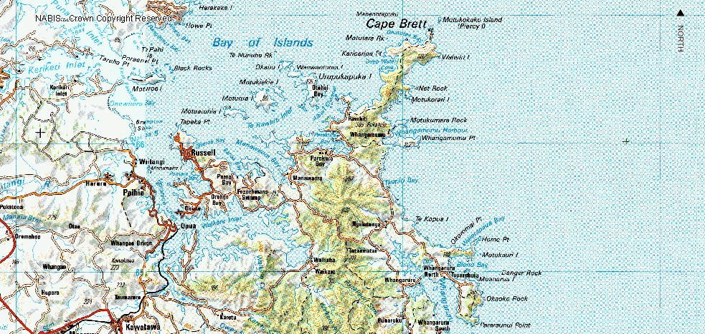
4
THE ROHE MOANA OF NGATI KUTA AND PATUKEHA
Our rohe kaitiakitanga begins at Taupiri on the eastern side to Tapeka in the west, from Wiwiki in the north to Motukokako in the south as set out in Map 1 below.

Map 1: Ngati Kuta and Patukeha rohe moana.
OUR CUSTOMARY STATUTORY RIGHTS
The 1996 Fisheries Act was enacted to promote the sustainable
utilisation
of
fisheries resources and have regard for Kaitiakitanga. This follows from the
Treaty of Waitangi Fisheries Claims Settlement Act (TOWFCSA) 1992). The TOWFCSA 1992 records that the Crown and MFish, have a Treaty duty to
recognise the use and management practices of tangata whenua and provide
active protection for the exercise of rangatiratanga in regard to customary fisheries. The Fisheries (Kaimoana Customary Fishing) Regulations 1998 allows for the establishment of rohe moana, tauranga ika and mahinga mätaitai to recognise and provide for customary food gathering by Maori and the special relationship between tangata whenua and the places which are of customary food gathering importance.
BACKGROUND

TANGATA WHENUA
We, Ngati Kuta and Patukeha ki Te Rawhiti, are the ahi kaa and we hold, because of this, mana moana and mana whenua (first rights on sea and land) in this rohe. This part of the coastline has been our primary means of subsistence for over 200 years, and before this, for hundreds of years, we held seasonal rights to gather kaimoana based on whakapapa and trade with other hapu.
Key
O
Maunganui Bay
5
The knowledge of ancient fishing practices and techniques has largely faded, but
has not gone and we have been piecing this knowledge together with great interest. The place of earliest sustained contact was the Bay of Islands. The impact of the Treaty of Waitangi rather than Te Tiriti, the land wars and the series of governmental organisations and policies forced widespread changes to our lives. We conserved our fishery for 800 years before the arrival of Cook, to such an extent that the biomass from 1769 to 1840 was rich and abundant as reported in “Between Two Worlds” by Professor Anne Salmond and in “Pre-European Fishing” by Foss Leach.
In the 200 plus years since this new population mix, the biomass has reduced
dramatically. Our oral histories and some present research show that the current conservation principles applied by the Ministry of Fisheries may need revision. We traditionally held rules based on rähui: limiting or banning taking of species in areas of the sea for a time when stocks were under pressure; the taking only of smaller to medium fish; a no-take on breeding stock and a rähui was placed on an area which showed signs of diminishing resources. Shellfish were cultivated like mahinga-gardens-with pipi transferred from plentiful beds to less plentiful. Where other shellfish like kutäi-mussel were under pressure in certain bays, a rähui would be imposed in those respective bays, whilst harvesting was allowed in other bays. This was a clear sign of long term sustainable utilisation planning.
In the 1920’s, the fishing huts at Deep Water Cove in Maunganui Bay were
established because of the proximity to the deep sea fish and the ease of trawling for bait, literally at the doorstep. By the 1950’s and 1960’s, whänau still recorded large schools of snapper, trevally, tarakihi, kahawai, pink and blue maomao, porae, banks of paua, scallops and an abundance of koura in Maunganui Bay. Sea grass meadows were also here, and was an area where. Pelagic fish congregated. Mutton birds were at Motukokako (the Hole in the Rock) and on the small islands.
IMPACTS ON CUSTOMARY USE AND MANAGEMENT
PRACTICES
Kaumatua recorded that there are no mutton birds now at Motukokako and on the small islands. There are very few takeke-piper now that there is no sea grass. The sea grass meadows were taken by the constant purse seine fishing where the trawlers constantly dragged through the bay because of the smooth, sandy bottom. Such treatment makes it understandable that the sea grass meadows in the bay disappeared and with them, kaimoana. We have concerns about the level of abundance as the stocks are fished out to Cape Brett. There are no more
banks of paua, with kina barrens being prolific.
Kaumätua note the loss of
flounder in the estuaries which may be caused by the sedimentation of their
habitat. A pipi beach has seen a significant loss of large pipi but it is used as a roadway at low tide, which has impacted negatively on the pipi growth.
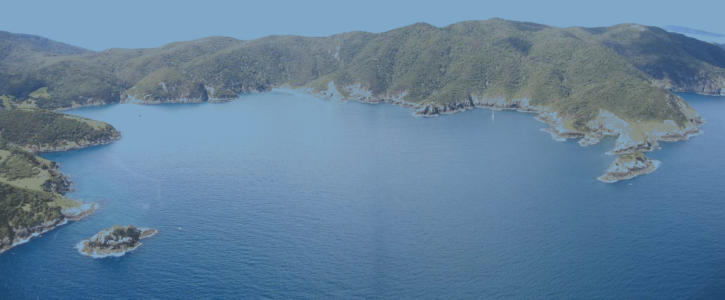
6
A prevailing idea of fishermen is that the biggest fish is the best catch 2 but those large fish are the breeding stock so that educating fishers about putting them
back is part of the fishery restoration. So depleted were the stocks, that Ngati Kuta and Patukeha began planning, after decades of whänau complaints, in
2004, for the re-building of the fishery discussing matters with Ministry of Fisheries, DOC and local fishermen. When Te Kupenga, the Fishery Plan, was
formed in 2006, the Frigate Waitaha-Canterbury became available and both hapu took the opportunity and purchased it so that it would become an artificial reef in
Maunganui Bay. This was to help build the fishery and as a catalyst to hapu economic development.
SPECIES AND BIOLOGICAL INFORMATION
On the advice of the kuia and kaumätua, the recreational divers, some marine scientists and a hydrologist, Maunganui bay was selected to sink the ex-frigate Waitaha-Canterbury. To assess the value of the wreck as an artificial reef before the scuttling, Ngati Kuta and Patukeha, funded by the Ministry of Fisheries, completed a baseline study of the fishery in and around Maunganui Bay in 2007, called Te Kupenga Manawahuna study. The aim was to investigate what fish were in Maunganui bay historically, from the evidence of the kuia and kaumätua of Ngati Kuta and Patukeha ki Te Rawhiti and written records, compared with the present stocks found in surveys in Maunganui in 2007.
Figure 2: Proposed S186A area,the 2007 survey sites and the two areas of subtropicalspecies
.
The decommissioned frigate Waitaha-Canterbury was scuttled on November 3,
2007. The pre- and post-scuttling surveys were in three sites noted above in Figure 2.
2 Snapper http://www.projectlocal.co.nz/index.php/snapper note: huge snapper fishermen are proudly holding!

Deep Wate

Subtropica species

r Cove

Site 1

Site 2

l

– Waitaha Reef

Putahataha Island

Site 3

MaunganuiB ay

Subtropical species

Motuw heteke Island

7
Site 1-where the frigate was to be sunk-the survey dives listed 37 species that
would set the baseline research for future studies. In January 2007 the first
19th
survey recorded one fish present and by
September 2007 eight shellfish
species and one fin fish were found at a depth of 28 metres and one sea bird.
Kelp was also recorded at this site. By January 2008, 5 months after the scuttling, there were 243 fish recorded at this site. The average number of fish was 122.
In Site 2-to the left of the bay-near Putahataha Island was a control point for Site
1. In September 2007 the surveys recorded 53 fin fish species and 61 shell fish species found at a depth of 20.6 metres. By August 2008 the surveys recorded
104 fin fish species and more than 40 shellfish. Of these, 118 were less then 10
cm including shellfish and only 25 species ranged from 10 up to 40 cm in length. There is an increase in species populations and an increase in size.
In site 3-to the right of the bay-the first survey undertaken in September 2007
recorded 19 shellfish and 116 fin fish species found at a depth of 15 metres. By August 2008 there were 71 fin fish species surveyed at this site. In terms of the artificial reef attracting more fish in to the bay, this seemed to be working as the reef was forming.
The fish were increasing with the establishment of the artificial reef. The 2007
December Monitoring Survey of the Canterbury artificial reef by J McKenzie from the Bay of Plenty Polytechnic, Tauranga showed an increase of fish present in the wreck with 16 species identified compared with 11 in July, 2007.
The sea grass meadows once held juvenile shellfish, crabs and fish nurseries
including the larvae brought down by the East Auckland tides. The Tasman current, moving down the east coast of NZ as the east Auckland current, carries
tropical and subtropical larvae, including invertebrates and fish.
They settle
along the east northland coast down to Cape Brett where recent studies showed
that of the 98 fish species found there, 29 are subtropical, and found in Maunganui bay (see Figure 2 above for area of subtropical species).
THE CUSTOMARY KAIMOANA IN MAUNGANUI BAY
However, according to the oral history interviews and written material, the following were most numerous in Maunganui bay; tipa-scallops pecten novaezelandiae, kina-sea urchin- evichinus chloraticus, tamure-snapper-pagrus auratus, koura-crayfish-jasus edwardsii, maomao-scorpis riolaceus, paua- abalone-haliotis iris and rimurimu takeke- seagrass-zostera capricorni. These fish and shellfish were the focus of the research undertaken in 2007 to 2008.
SEA GRASS-RIMURIMU TAKEKE
Today there are no sea grass meadows in Maunganui bay. The 2007/08 surveys concluded that further research and monitoring of the sea grass in Urupukapuka
8
bay was required to identify other places in Ipipiri, to locate known areas of sea
grass meadows. An unsuccessful application was made to MFish in late 2008 for funding of a survey for sea grass and investigation into re-planting. The hapu
have been consulting with NIWA and their sea grass replanting in the Whangarei
harbour. The Northern Regional Council now has a sea grass survey project accepted for this year. This survey will be carried out in the south-eastern Bay of Islands at the initial request of our hapu.
SCALLOPS-TIPA
Scallops are no longer present in Maunganui, though the empty shells are visible. There will be further research into past commercial and recreational scallop fisheries within Ipipiri (south eastern Bay of Islands). After much discussion with NIWA, in November 2008, Dr James Williams and men from our hapu began a re-seeding programme for scallops in Ipipiri. This is one of 18 scallop re-seeding places from Rangaunu and Doubtless bays in the north and down the coast to Bream Point, south of Whangarei.
Figure 3: Scallop placements around Te Rawhiti
Three lines of scallops called moorings have been set; one in Maunganui bay,
one at Poroporo Island and one at Tokapiko near Omakiwi. They were picked up on January 14, 2009, and replaced with new ones and this was repeated in August, 2009. The results, showing how well or not the scallops grew in their mooring environments, will be available in next year.
SNAPPER-TAMURE, CRAYFISH- KOURA
There are few snapper though the schools are growing. Further research into historical fishing practices are to be explored. Research is needed for other options and methods to protect tamure and koura aside from Mataitai and regulations, including traditional methods. In the first survey in the Waitaha- Canterbury, two crayfish were found in the engine room. These were taken by divers soon after.

Eight months later, a commercial fisher set pots in Maunganui bay. We note that for many years because of the disappearance of the koura, there were no pots laid, within months of the sinking of the Waitaha-Canterbury commercial fishers
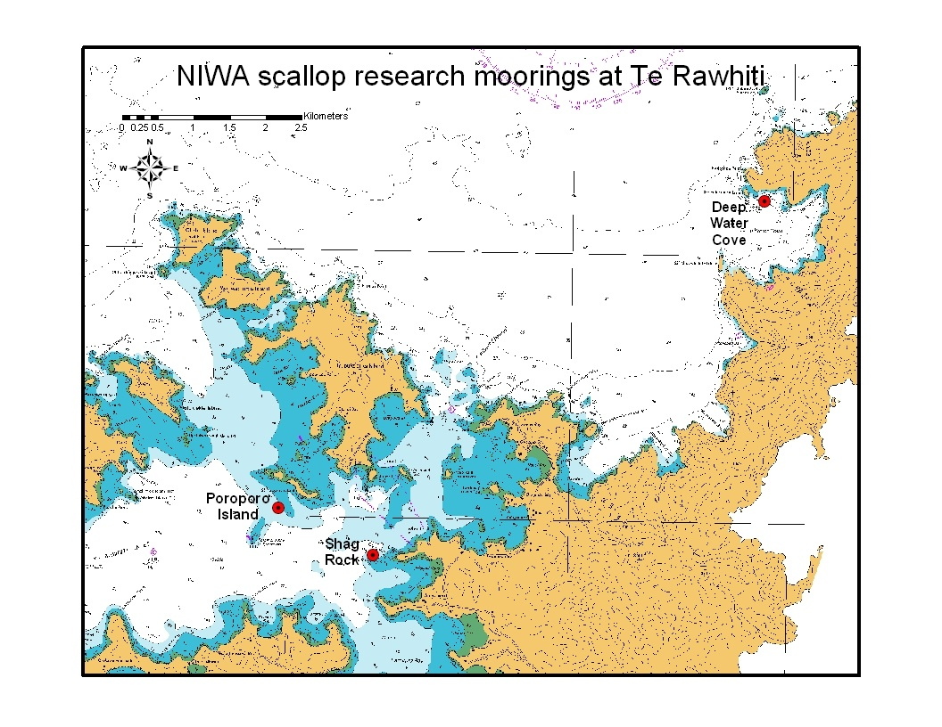

9
took advantage of the small gains that we have put in place. The indication is that
crayfish may be increasing, but many known holes are still empty.
MAOMAO, ABALONE-PAUA
Ongoing surveys are to be held to identify whether maomao are returning to school in Maunganui. There is anecdotal evidence that maomao still appear there, as they are known to school in open water and by rocky structures where they sleep at night.
There are no paua in the bay but again the empty shells are there. There needs
to be a project studying paua. Kina have been documented as capable of ‘bulldozing’ juvenile paua during their grazing.3 The large starfish, astrostole scabra, are also known to eat paua.
Figure 4: Shells under the wreck evidence that there were once shellfish in Maunganui
SEA URCHIN-KINA
The kina are where the paua banks were, an indication that kina barrens are prolific and appears that the ecosystem is out of balance. Reviewing kina research is a future study. There has been a great deal of research in to the kina (evechinus chloroticus) which is common in the Bay of Islands but the population is mixed now with the southeast australian sea urchin, centrostephanus rodgersii (it has long spines) along the Cape Brett peninsula and in Maunganui bay. Kina
primarily feed on the common kelp ecklonia radiata.
Koura is a significant
predator of kina and large koura (100mm) eat all sizes of kina, while smaller
koura (40mm) can attack juvenile kina. Abundant kina may show that there are very few koura in Maunganui.
Severe storms can remove kelp forests and large numbers of kina feeding on
juvenile kelp and drift kelp can keep kelp forests from re-growing. Kina predators are crabs, starfish (the seven-armed astrostole scabra), snails, some birds,
snapper, and us, humans.
3 Andrews N. I., Biological Aspects of the common Sea Urchin, Evechinus chloroticus, in northern New Zealand: A Review. New Zealand Journal of Marine and Freshwater Research. 22: 415-426

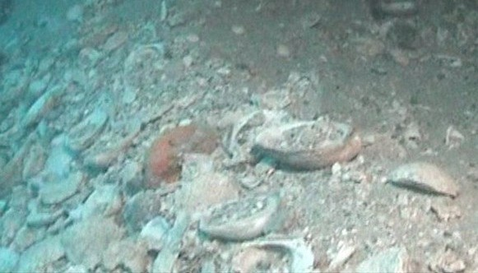

10
AREA AND BOUNDARY OF THE S186A MAUNGANUI
BAY
Map 2
Area and Boundary of s186A Maunganui Bay
The area for the S186A is set out in the map
above and we propose that
the
line
following are the designated points; from Kariparipa Point in a straight
10metres north of Putahataha Island in a straight line to 10 metres off
Motuwheteke Island to the tauranga ika on the other side.
FISHING METHODS RESTRICTION
We want to prohibit all fishing methods in Maunganui bay including:
line fishing

pots or hinaki for koura spear fishing
net fishing purse seining trawling
and any other methods. “Look but don’t touch’ captures this ban.
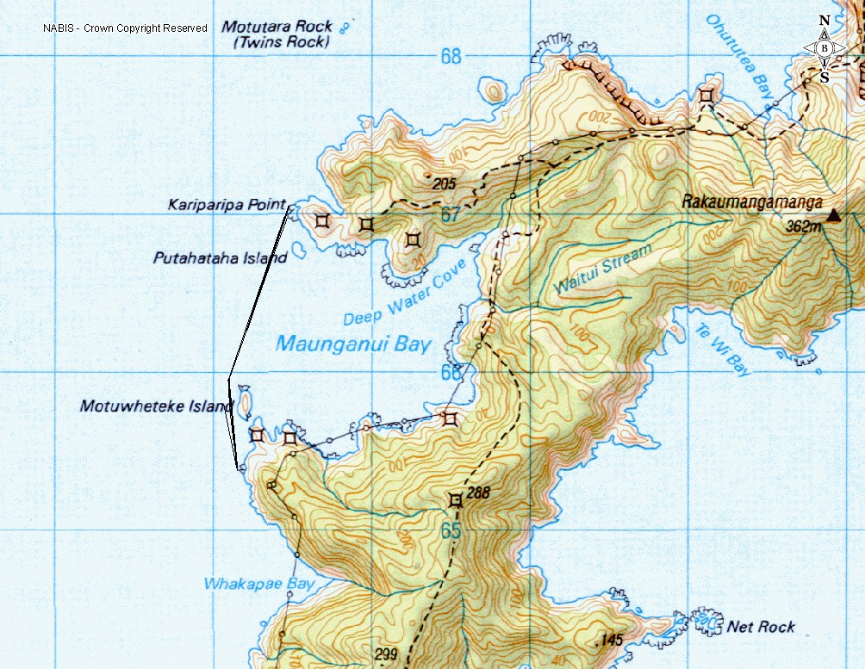

11
LENGTH OF S186A RESTRICTION
We want the S186A to be placed on Maunganui Bay for two years, and if there is still a requirement to renew the S186A.
CONSULTATION ALREADY UNDERTAKEN
We have carried out consultation with the following people; Ngati Kuta and Patukeha ki Te Rawhiti
The Eastern Bay of Islands Preservation Society

Department of Conservation Ministry of Fisheries
The rahui notified on March 17, 2009, has meant that the public and fishery organisations have been aware of our plan to re-build the fishery for eight months.
SUMMARY
This application for a section 186A in Maunganui bay is born out of a total concern for the sustainable utilisation of our fishery in the Bay of Islands. The customary declaration of a rähui in Maunganui-‘Look but don’t touch’- was an appeal to the conscience of fisher folk, to take a different approach to fishing and allow the rejuvenation of the fishery in Maunganui Bay, which has been severely depleted over the years by all users.
In the short term, a S186A will assist in providing in the long term sustainable
utilisation of the fishery not only for customary purposes but also for the benefit of the wider fisher and consumer communities. It is an approach to provide for
future generations by enabling the fishery to rebuild to a healthy sustainable state
including the various sub-tropical and tropical fish, kaimoana ecologies, and birds, all of which existed interdependently in Maunganui bay.
Kia ora,
Helen Mountain Harte Project Manager
On behalf of Te Kupenga o Ngati Kuta and Patukeha ki Te Rawhiti

12
BIBLIOGRAPHY
Te Kupenga Fishery Plan www.terawhitimarae.maori.nz Our Projects
Snapper http://www.projectlocal.co.nz/index.php/snapper note: huge snapper
fishermen are proudly holding!
Andrews N. I., Biological Aspects of the common Sea Urchin, Evechinus
chloroticus, in northern New Zealand: A Review. In New Zealand Journal of Marine and Freshwater Research. 22: 415-426
“Between Two Worlds” First Meetings between Maori and Europeans 1642-1772
A Salmond. Viking. Auckland. 1991
“Fishing in Pre-European New Zealand” Foss Leach NZ Jnl of Archaeology and

Archaeofauna. 2006

